MORE ON MATRICES
The Colon Operator
To generate a vector of equally – spaced elements MATLAB provides the
Colon operator. Try the following commands:
1:5
0:2:10
0:0.1:2*pi
- Positive increment
>>X=0.0:0.5:2:0
X =
0 0.5000 1.0000 1.5000 2.0000
- Negative increment
>>Y=10:-1:4
Y =
10 9 8 7 6 5 4

The syntax x: y means roughly ‘’generate the ordered set of numbers from x to y with increment 1 between them’’. The syntax x: d: y means roughly ‘’generate the ordered set of numbers from x to y with increment d between them’’.
1.6 LinSpace
To generate a vector of evenly spaced points between two end points,
You can use the function linspace (start, stop, № of points):
>> x=linspace(0,1,10)
x =
Columns 1 through 6
0 0.1111 0.2222 0.3333 0.4444 0.5556
Columns 7 through 10
0.6667 0.7778 0.8889 1.0000

3.1 Typing Matrices
To type a matrix into MATLAB you must
- Begin with a square bracket [
- Separate elements in a row with commas or spaces
- Use a semi colon (;) to separate rows
- End the matrix with another square bracket ]
For example, a 3x5 matrix B with the following elements:
first row: 1, 0, 9, 4, 3
second row: 0, 8, 4, 2, 7
third row: 14, 90, 0, 43, 25
would be entered in MATLAB as follow:
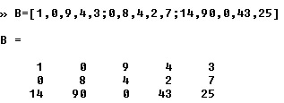
Note that you may use a space in place of the comma in separating the column entries.
Matrix Concatenation
>>a=[1 2 3], b=[7 9 4], c=[1 3 5 8]
then
>>d=[a b c]
D =
1 2 3 7 9 4 1 3 5
>> d=[a;b;c]
d =
1 2 3
7 9 4
1 3 5

Indexing vectors and matrices.

You may extract a certain group or element from an existing matrix. Say you wish to create a new array C from the second row of matrix B. Specify the row number and ":" for all columns in that row as shown below:
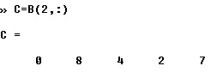
Similarly, You may also form a matrix from the element of an existing matrix:
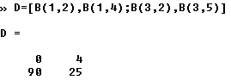
>> my_matrix = [8, 12, 19; 7, 3, 2; 12, 4, 23; 8, 1, 1]
my_matrix =
8 12 19
7 3 2
12 4 23
8 1 1
- To access the value of 4 you would type in
- my_matrix(3,2)
ans = 4
- Note: The row number is first, followed by the column number.
- The colon (:) operator means ‘ALL’.
- You can also extract any contiguous subset of a matrix, by referring to the row range and column range you want. For example, if mat is a matrix with 5 rows and 8 columns, then typing
- mat(2:4,4:7) would extract all elements in rows 2 to 4 and in columns 4 to 7.
Create matrix c as shown below at the command prompt and press the enter key
>> c = [1 3 6; 2 7 9; 4 3 1]

Extract element at the 3rd row,1st column as shown below.you should get 4.

- >>c(3,1)
- >>c(2:3,1:2) gives you the elements in rows 2 to3, and columns 1to2, so you will get
2 7
4 3
- >>c(1:3,2) gives you the elements in rows 1-3, and the second column, that is, the entire second column. Which is:
3
7
3
You can shortcut this to:
>>c(:,2)
.

- >> B = [ 1 2 3;4 5 6;7 8 9]
B =
1 2 3
4 5 6
7 8 9
- >>B(2,2) =5
- >>B(:,2) =
ans =
2
5
8
- >>B([1 3],:) % selects the first and third rows, all the columns.
ans =
1 2 3
7 8 9
- U= B([3 2 1],:) % reverses the rows of B
U =
7 8 9
4 5 6
1 2 3

Ends as a Subscript
To access the last element of a matrix along a given dimension, use end as a subscript .This allows you to go to the final element without knowing in advance how big the matrix is. For example:
>> q=4:10

q =

4 5 6 7 8 9 10

>> q(end)

ans =

10
q(end-4:end)

ans =

6 7 8 9 10
Practice
Create a 5-by- 4 matrix
Find
a.the last row, all the columns
b.the 2nd and 4th rows,the last column

3.6.1 Deleting Rows or Columns
To get rid of a row or column set it equal to the empty matrix [].
a=[1 2 3;4 5 6;7 8 9]
a =
1 2 3
4 5 6
7 8 9

>> a(:,2)=[] % deletes the all the rows the second column.
a =

1 3
4 6
7 9

Using MATLAB built-in functions to Concatenation matrices
The functions to be used are vertcat and horzcat.

1. vertcat
Concatenate arrays vertically

Syntax
C = vertcat(A1, A2, ...)

Description
C = vertcat(A1, A2, ...) vertically concatenates matrices A1, A2, and so on. All matrices in the argument list must have the same number of columns.
vertcat concatenates N-dimensional arrays along the first dimension. The remaining dimensions must match.
MATLAB calls C = vertcat(A1, A2, ...) for the syntax C = [A1; A2; ...] when any of A1, A2, etc. is an object.

Examples
Create a 5-by-3 matrix, A, and a 3-by-3 matrix, B. Then vertically concatenate A and B.
A = magic(5); % Create 5-by-3 matrix, A
A(:, 4:5) = []

A =

17 24 1
23 5 7
4 6 13
10 12 19
11 18 25

B = magic(3)*100 % Create 3-by-3 matrix, B

B =

800 100 600
300 500 700
400 900 200

C = vertcat(A,B) % Vertically concatenate A and B

C =

17 24 1
23 5 7
4 6 13
10 12 19
11 18 25
800 100 600
300 500 700
400 900 200

2. horzcat
Concatenate arrays horizontally

Syntax
C = horzcat(A1, A2, ...)

Description
C = horzcat(A1, A2, ...) horizontally concatenates matrices A1, A2, and so on. All matrices in the argument list must have the same number of rows.
horzcat concatenates N-dimensional arrays along the second dimension. The first and remaining dimensions must match.
MATLAB calls C = horzcat(A1, A2,...) for the syntax C = [A1 A2 ...] when any of A1, A2, etc., is an object.

Examples
Create a 3-by-5 matrix, A, and a 3-by-3 matrix, B. Then horizontally concatenate A and B.
A = magic(5); % Create 3-by-5 matrix, A
A(4:5,:) = []

A =

17 24 1 8 15
23 5 7 14 16
4 6 13 20 22

B = magic(3)*100 % Create 3-by-3 matrix, B

B =

800 100 600
300 500 700
400 900 200

C = horzcat(A, B) % Horizontally concatenate A and B

C =

17 24 1 8 15 800 100 600
23 5 7 14 16 300 500 700
4 6 13 20 22 400 900 200

Special Matrices in Matlab

1. eye
Identity matrix

Syntax
Y = eye(n)
Y = eye(m,n)
eye([m n])

Example:
- eye (3)
ans =
1 0 0
0 1 0
0 0 1

eye(3,4)

ans =

1 0 0 0
0 1 0 0
0 0 1 0

2. zeros
Create array of all zeros

Syntax
B = zeros(n)
B = zeros(m,n)
B = zeros([m n])

Example
s=zeros(3) % 3x3 matrix

s =

0 0 0
0 0 0
0 0 0

3. ones
Create array of all ones

Syntax
Y = ones(n)
Y = ones(m,n)
Y = ones([m n])
Y = ones(size(A))

Example
- ones(2,4)
ans =
1 1 1 1
1 1 1 1

5. rand
Uniformly distributed pseudorandom numbers

Syntax
r = rand(n)
rand(m,n)
rand([m,n])

Examples
rand(3)
ans =
0.8147 0.9134 0.2785
0.9058 0.6324 0.5469
0.1270 0.0975 0.9575
Try rand(3,4)

6. randn
Normally distributed pseudorandom numbers

Syntax
r = randn(n)
randn(m,n)
randn([m,n])

Examples
randn(4)

ans =

2.7694 -0.0631 1.4897 -1.2075
-1.3499 0.7147 1.4090 0.7172
3.0349 -0.2050 1.4172 1.6302
0.7254 -0.1241 0.6715 0.4889
Try randn(4,5)

magic
Magic square

Syntax
M = magic(n)
M = magic(n) returns an n-by-n matrix constructed from the integers 1 through n^2 with equal row and column sums. The order n must be a scalar greater than or equal to 3.

Examples
The magic square of order 3 is
M = magic(3)

M =

8 1 6
3 5 7
4 9 2
This is called a magic square because the sum of the elements in each column is the same.
Try magic(5)

MATRIX ARITHMETIC
MATLAB treats arithmetic operations on arrays in an element-by-element manner. This operation is accomplished by including a dot or a period before the arithmetic operator such as multiplication, division, etc. The table below gives a list of such operators with examples of how these operators are being used.
For examples in the table below, the following matrices are used: try working as read along.
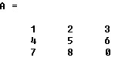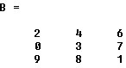
Operation | Description | Example (MATLAB actual inputs and outputs)
+ | Addition | 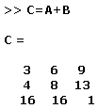
- | Substraction | 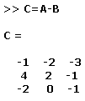
* | Multiplication | 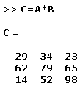
.* | Element-by-element multiplication.  Note that this is different from multiplication of two matrices. | 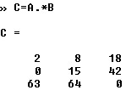  Note that this is not the same as C = A*B
/ | Right matrix division.  Dividing matrix B into matrix A | 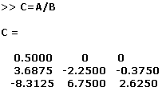
\ | Left matrix division.  Dividing A into B. This is equivalent to inv(A)*B. Note that X = C is the solution to A*X=B | 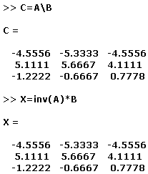
./ | Element-by-element division  note that D(2,1) is undefined due to the zero at B(2,1) | 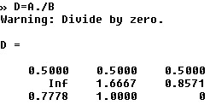
.\ | Element-by-element left division.Note that left division in this particular example means elements of B divided by the corresponding elements of A. | 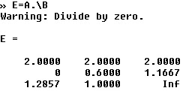
.^ | Element-by-element power | 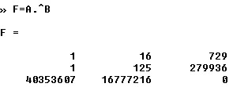

Transposing a matrix in MATLAB involves a simple prime notation ( ' ) after the defined matrix as shown below:
Example:
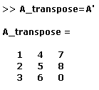
NB: the function transp can also be used for the same output.
Sorting columns and rows follow the syntax: B=sort(A,dim), where dim is the dimension of the matrix with the value 1 for column; 2 for row. Matrix A is the variable specified by the user.
Example:
Sorting columns:
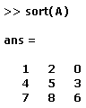
Note that without dim being specified, the default value is 1. The default setting is ascending order. The variable name of the sorted matrix can be omitted if no needed.
Sorting column in descending order:
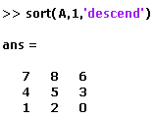
Sorting row in descending order
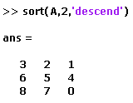

The inverse of matrix A can be obtained with the command:
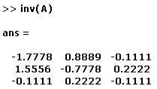
Determinat of a matrix(det)

Syntax
d = det(X)

Examples
A = [1 2 3; 4 5 6; 7 8 9]
d = det(A)
d=0

Eigenvalues and Eigenvectors can easily be obtained with the command [V,E]=eig(matrix name):
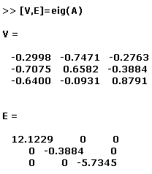
where matrix V consists of Eigenvectors . The corresponding Eigenvalues are shown in matrix E. Eigen values alone can be obtained without the notation "[V,E]":
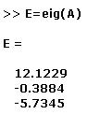
Finding the size of a matrix
The following syntax finds the size of a matrix:
d = size(X)
[m,n] = size(X)
m = size(X,dim)
Where m=number of rows and n=number of columns.
PRACTICE
Enter matrix q as shown below
>>q=[2 3 4 1;6 3 8 9;1 5 3 6]
>> size(q)
ans =
3 4
find
1 >> [m n]=size(q)
2 >> m=size(q,1)
3 >> n=size(q,2)
EXERCISE
Create
- 5-by-4 matrix, X
- 7-by-6 matrix, Y
- Delete all the roles, the second column of matrix X
- Delete all the columns, the last row of matrix Y
- Find the size MATRIX X and Y
- concatenate X and Y. Vertically and Horizontally using vertcat , horzcat and the normal way.

Diagonal of a matrix
The command diag has two uses.
- The first use is to extract a diagonal of a matrix.
syntax
v = diag(X) returns the main diagonal of X.
Example
A = [1 2 3; 4 5 6; 7 8 9]
D=diag(A)
- The second use is to create diagonal matrices.

Examples
d=diag([2;1;3;4])
A = diag([12:4:32])

Reshaping matrices

Syntax
B = reshape(A,m,n)
B = reshape(A,m,n), returns the m-by-n matrix B whose elements are taken column-wise from A. An error results if A does not have m*n elements.

Examples
Reshape a 3-by-4 matrix into a 2-by-6 matrix.
A =
1 4 7 10
2 5 8 11
3 6 9 12

B = reshape(A,2,6)

B =
1 3 5 7 9 11
2 4 6 8 10 12

Replicating a Matrix. Use the repmat function to create a matrix composed of copies of an existing matrix. When you enter
repmat(M, v, h)
MATLAB replicates input matrix M v times vertically and h times horizontally. For example, to replicate existing matrix A into a new matrix B, use
A = [8 1 6; 3 5 7; 4 9 2]

B = repmat (A, 2, 4)

1.fliplr – flip the matrix about the vertical axis(Flip matrix left to right).

Syntax
B = fliplr(A)
Example
1 s=magic(4)
B = fliplr(s)
2. A= 1:2:9
X= fliplr(A)

2 flipud-flip the matrix about the horizontal axis(Flip matrix up to down).

Syntax
B = flipud(A)
>> A=[(1:3)’ (4:6)’]

>> B= flipud(A)
B = 3 6
2 5
1 4
2. >> A=3:2:7
>> B=flipud(A)
B=
7
5
3

3 flipdim- Flip the matrix along the specified direction.

Syntax
B = flipdim (A,dim)
B = flipdim (A, dim) returns A with dimension dim flipped.
When the value of dim is 1, the array is flipped row-wise down. When dim is 2, the array is flipped columnwise left to right. flipdim(A,1) is the same as flipud(A), and flipdim(A,2) is the same as fliplr(A).

Example
A=[(1:3)’ (4:6)’]

>> B= flipdim(A,1)
B = 3 6
2 5
1 4
Try flipdim(A,2).what did you get?

Learn more using matlab help file.

